Spring 2025
Cse-5392 wireless Communications
the university of texas at arlington


lab 3 report
Submitted toward the partial completion of the requirements for CSE 5392
Under the guidance of
Prof. Jason Losh
By:
Dario Ugalde, 1001268068

Introduction
This lab focused on the effects of variable cabling and how the HMC189 frequency doubler the loss experienced by an RF system. This concept was explored in a practical manner. The lab begins by identifying a baseline dBm loss with a wire of a known length by connecting the RF generator directly to the Spectrum Analyzer with this known cable. Additional cable types and the frequency doubler were then introduced to understand the impact of interchanging cables of various types. The following sections document and describe our team’s findings.

Steps 1 – 5: Baseline Loss Measurements
To begin the lab, the RF Generator and Spectrum Analyzer were configured according to the specifications in the lab guide. The two devices were then connected directly using the reference cable. The lab guide provides instructions to steadily increase the frequency of the RF Generator and capture the loss readings. Our readings and screen captures are provided in the following Figures.

Short (Ref)
Freq. | Power (dBm)
100 MHz | -19 .82
250 MHz | -20.20
500 MHz | -20.43
1 GHz | -20.7
2 GHz | -21.82
4 GHz | -25.6
Figure 1. Loss in dBm as captured using the reference cable
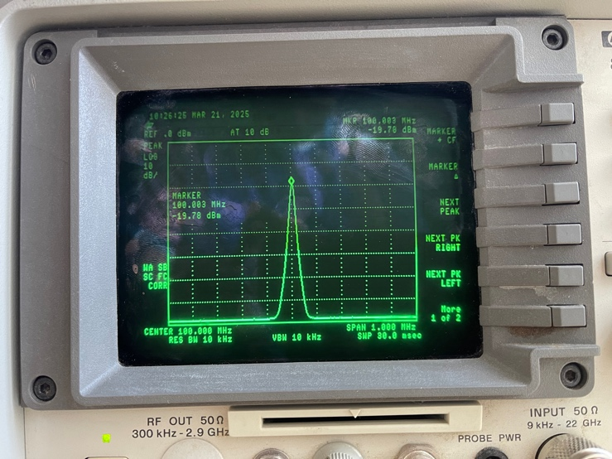
Figure 2. Spectrum Analyzer capture receiving 100MHz signal
Based on the acquired data, it can be inferred that increasing RF signal frequency results in increased loss across a medium. In class, we discussed how some of the energy of the produced frequencies can be dissipated as heat from our medium. This is important to note as RF system design must take this factor into consideration to maximize system efficiency.

Step 6: Loss of Varying Cable Types
For the next section of the lab, varying cable types were added in between the reference cable and the Spectrum Analyzer. Our findings are documented below:

6’ RG316 Cable Readings

6' RG316
Freq. | Power (dBm)
100 MHz | -20.46
250 MHz | -21.19
500 MHz | -21.83
1 GHz | -22.78
2 GHz | -25.01
4 GHz | -29.54
Figure 3. Loss measurements at various frequencies for 6' RG316 cable

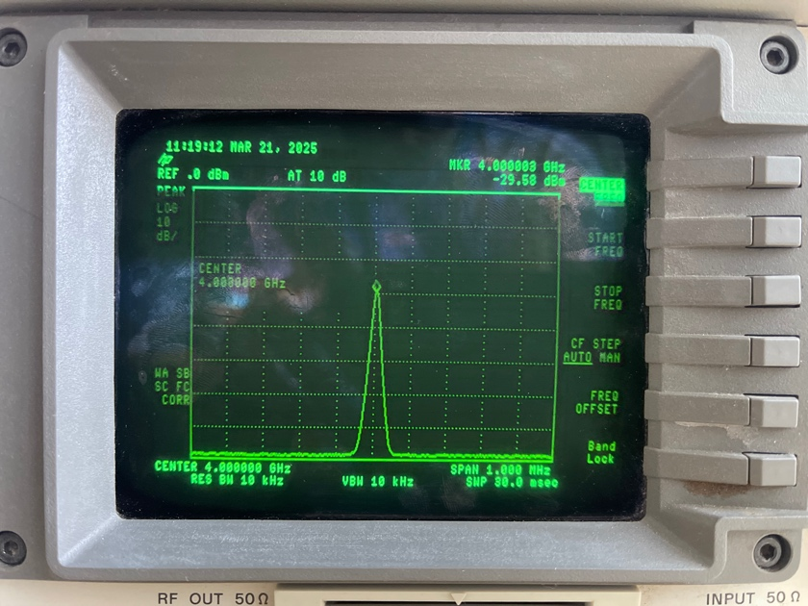
Figure 4. Spectrum Analyzer capture of 6' cable at 4GHz
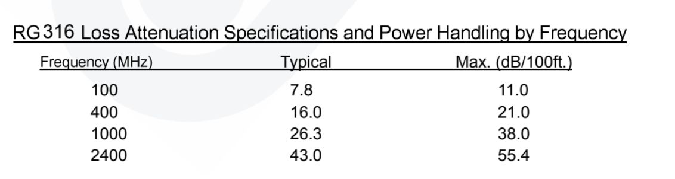
Figure 5. RG316 Loss specifications from its datasheet
According to its datasheet, as shown in Figure 5 above, the RG316 cable will typically result in a loss of 7.8dB/100ft and a max loss of 11.0dB/100ft at 100MHz frequencies. In our measurements above, having used a 6’ cable should yield roughly 16.6 times less loss as what is defined by the manufacturer. Going off our measurements, which take into consideration the insertion loss produced by this cable at 0.64dBm at 100MHz, we can multiply that by 16.6 to get 10.6dB/ft which is in range of the manufacturer specification.

3m UFA 210B Cable Readings

UTiFlex UFA 210B
Freq. | Power (dBm)
100 MHz | -20.18
250 MHz | -20.67
500 MHz | -21.07
1 GHz | -21.69
2 GHz | -23.69
4 GHz | -26.8
Figure 6. Loss measurements at various frequencies for the UFA 3m cable
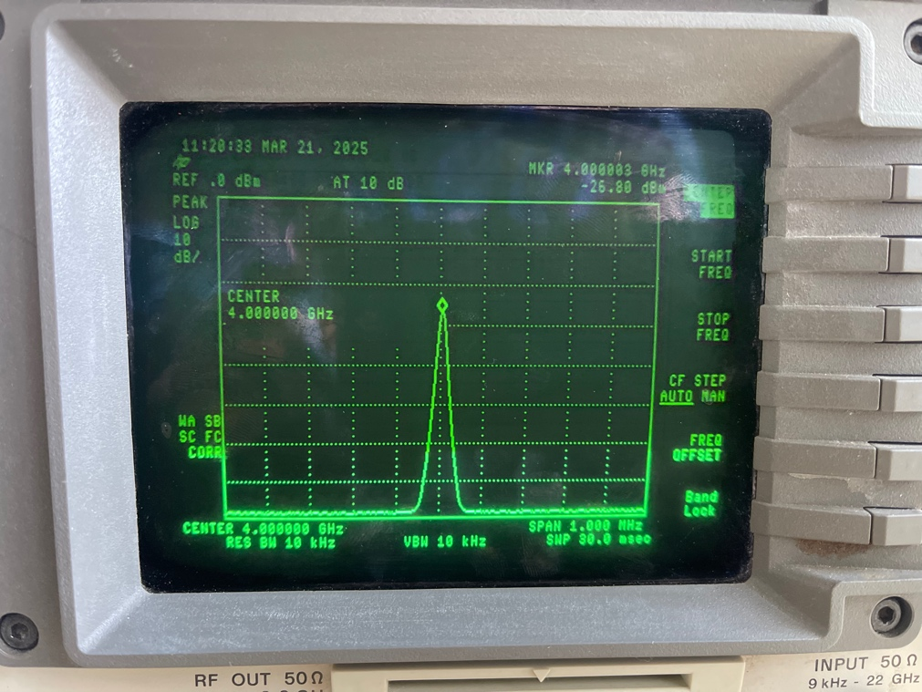
Figure 7. Spectrum Analyzer capture of UFA 3m cable at 4GHz
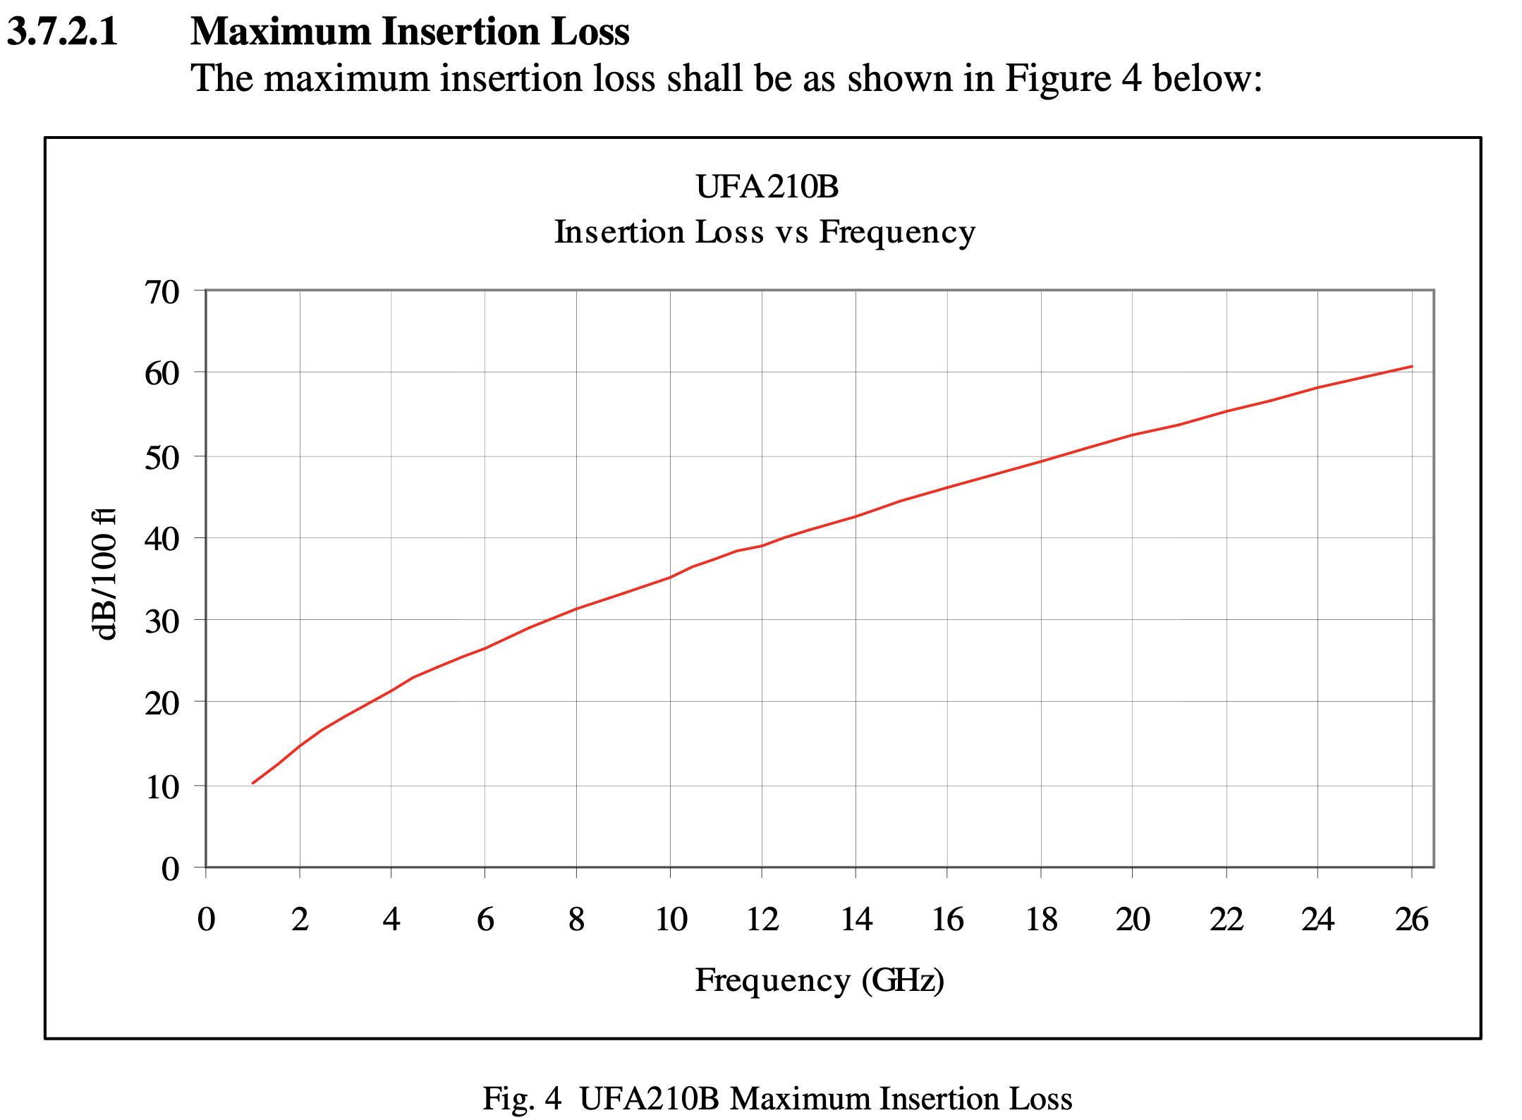
Figure 8. UFA 210B Insertion Loss Graph from datasheet
Based on the graph shown in Figure 8, the utiflex coax cable experiences loss of about 10dB/100ft at frequencies near 1GHz. In our measurements, we used a 3m cable which is around 9.84ft. To approximate our conversions, we would need to multiply our reading by 10.16 to match our 3m cable reading to the 100ft manufacturer specification. The measured insertion loss for our segment of cable was measured around 0.99dBm. Using this number and multiplying it by our 10.16 factor from before results in loss of 10.05dB/100ft, which is in line with the expected manufacturer specification.

14’ SuccoFlex Cable Readings

14' Succoflex 1/2'' HF
Freq. | Power (dBm)
100 MHz | -20.07
250 MHz | -20.5
500 MHz | -20.85
1 GHz | -22.47
2 GHz | -23.36
4 GHz | -26.69
Figure 9. Loss measurements at various frequencies for 14' Succoflex cable
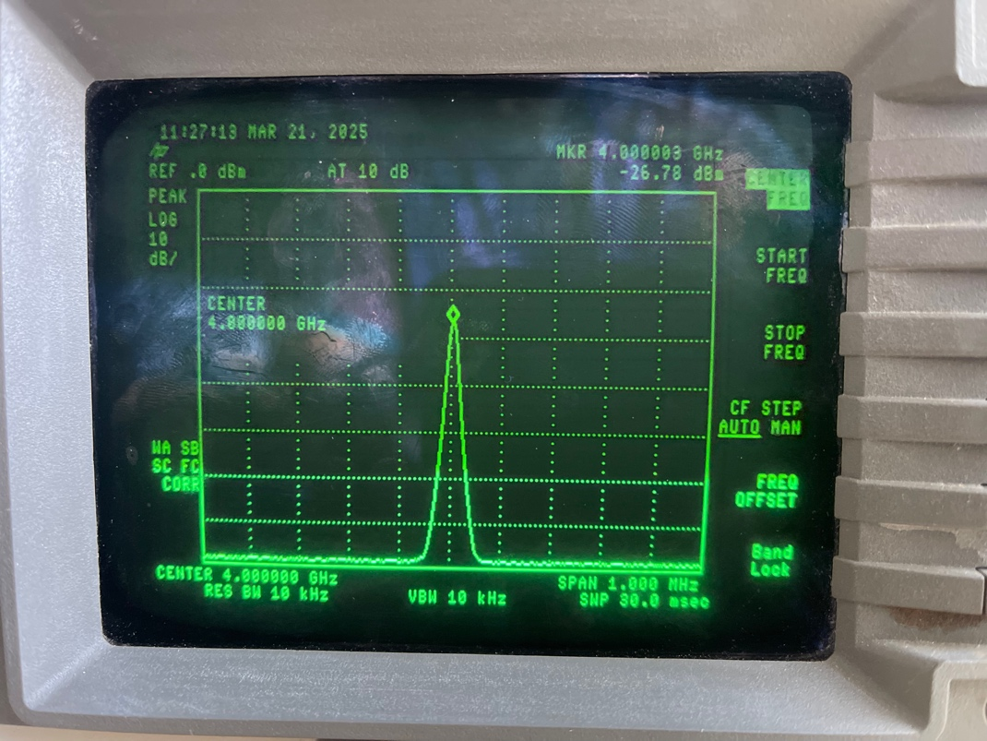
Figure 10. Spectrum Analyzer capture of 14' Succoflex cable at 4GHz

The Succoflex cable proved to be difficult to find the relevant documentation. However, what documentation was found for the various types of Succoflex coax cables mentioned this cabling was meant for high performance, low loss environments. As such, it is expected this cable will have a significantly lower dB/100ft loss than the previous types. Straight away, it is evident for the measurement points this cable had the lowest insertion loss despite being the longest cable used for this lab.

Steps 7 – 10: Loss of HMC189 Frequency Doubler
For the next portion of the lab, an HMC189 frequency doubler was placed between the reference cable and the Spectrum Analyzer. The following table documents our measurements at various frequencies:

6 inch (Ref)
Freq. | Power (dBm)
2 GHz | -12.32
3 GHz | -16.5
4 GHz | -27.66
Figure 11. Loss measured in dBm at various frequencies with HMC189 frequency doubler
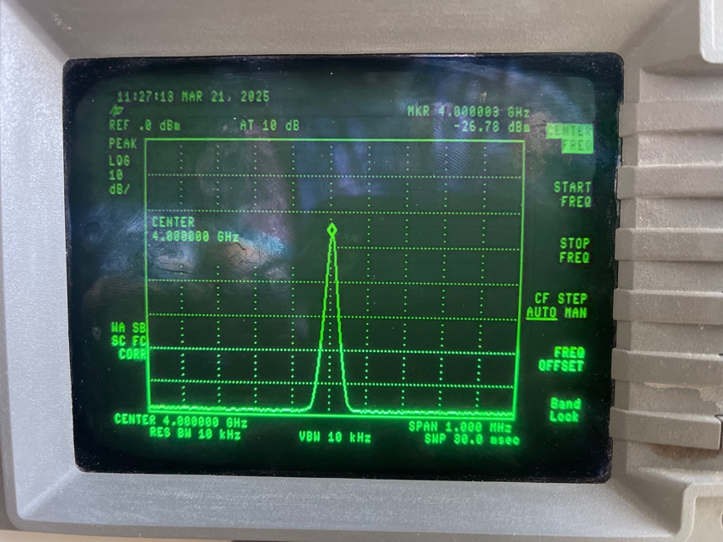
Figure 12. Spectrum Analyzer capture of HMC189 output at 8GHz
The Spectrum Analyzer was configured to provide an output of 10dBm so it was interesting to see that the HMC189 inserts a fair amount of loss into the system. This provides yet another example of why part selection must be thought through carefully to ensure the desired outputs are produced because of adding components to a system. In this example, the frequency doubler doubles the frequency at the expense of doubled loss with every 1GHz step. After a certain point, there will be diminishing returns where a more effective component will need to be selected depending on the system’s requirements.

Step 11: Loss of Variable Cables with HMC189
The last bit of the lab was a repeat of step 10 with various cables placed between the frequency doubler and the Spectrum Analyzer. Our measurements are captured and described in the following sections:

6’ RG316 Cable Readings

6' RG316
Freq. | Power (dBm) | Insertion Loss (dBm)
2 GHz | -19.63 | -7.31
3 GHz | -24.75 | -8.25
4 GHz | -36.09 | -8.43
Figure 13. Loss measurements of RG316 and HMC189 configuration
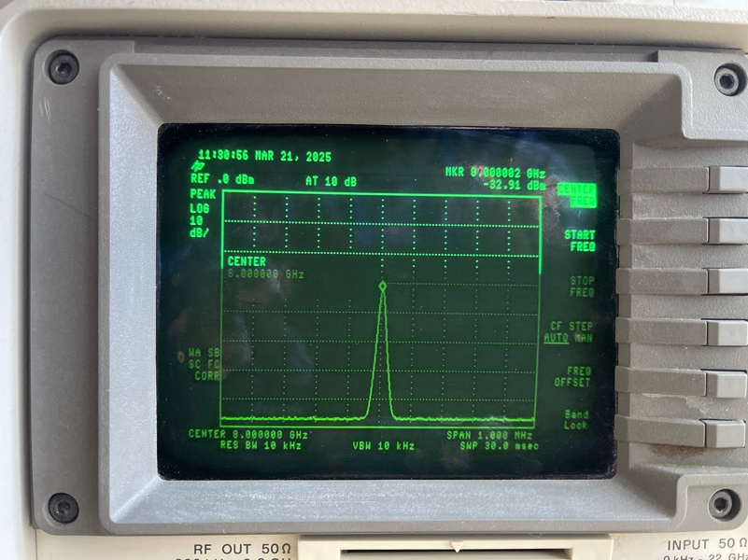
Figure 14. Spectrum Analyzer capture of the 8GHz HMC189 output with RG316

3m UFA 210B Cable Readings

UTiFlex UFA 210B
Freq. | Power (dBm) | Insertion Loss (dBm)
2 GHz | -14.02 | -1.7
3 GHz | -16.45 | 0.5
4 GHz | -29.24 | -1.58
Figure 15. Loss measurements of UFA 210B and HMC189 configuration
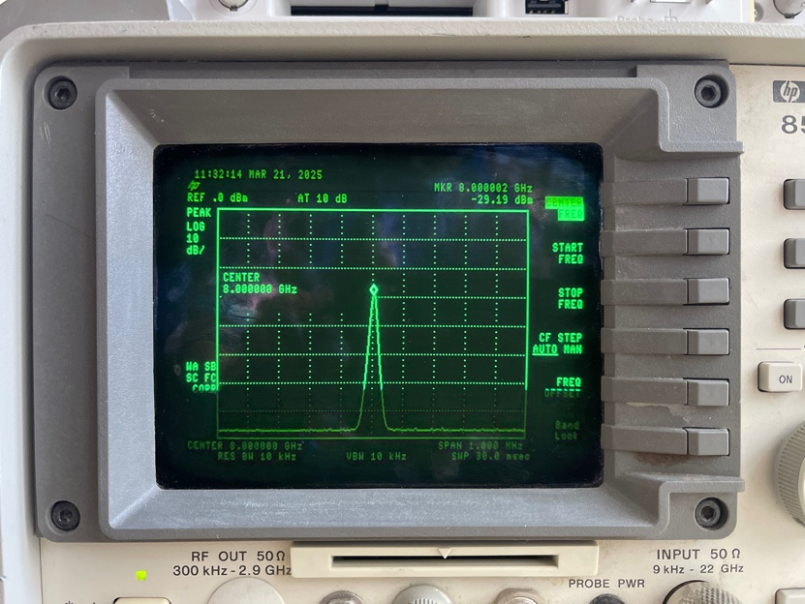
Figure 16. Spectrum Analyzer capture of the 8GHz HMC189 output with UFA

14’ SuccoFlex Cable Readings
14' Succoflex 1/2'' HF
Freq. | Power (dBm) | Insertion Loss (dBm)
2 GHz | -15 | -2.68
3 GHz | -16.25 | 0.25
4 GHz | -28.7 | -1.04
Figure 17. Loss measurements of Succoflex and HMC189 configuration
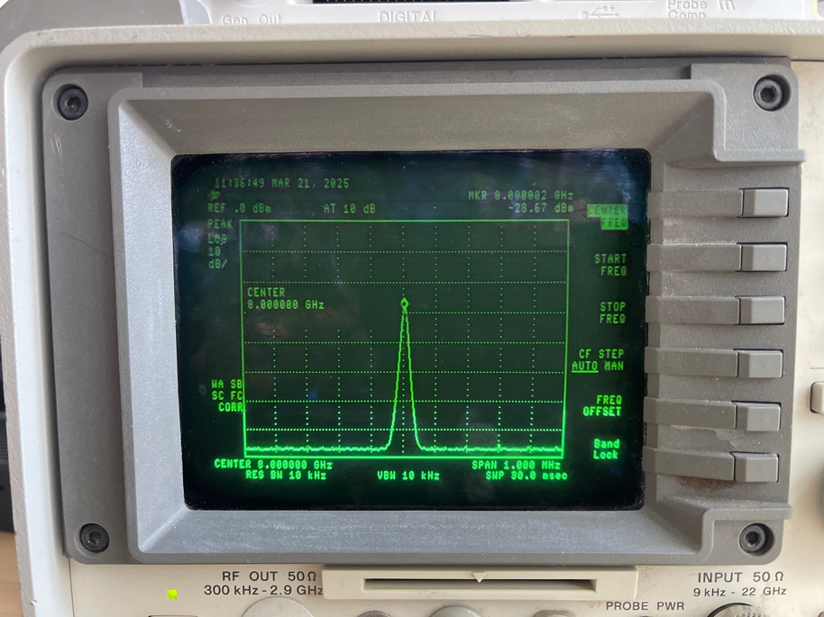
Figure 18. Spectrum Analyzer capture of the 8GHz HMC189 output with Succoflex

For our UFA and Succoflex loss readings at 3GHz we have some unexpected values where there appears to be gain rather than loss. The other values appear correct so there may have been an error in writing down the values at the time of the lab or perhaps an error in our configuration.

Conclusion
This lab provided a simple and intuitive method of understanding how introducing
components and cabling to an RF system can impact the loss experienced by the system. It provided examples of varying performance at different price points where the RG316 coax is most cheaply available and can cost around $36 for 100ft and Succoflex being about $65 for 3m. These are important factors that must be taken into consideration when designing devices depending on the needs of the consumer.

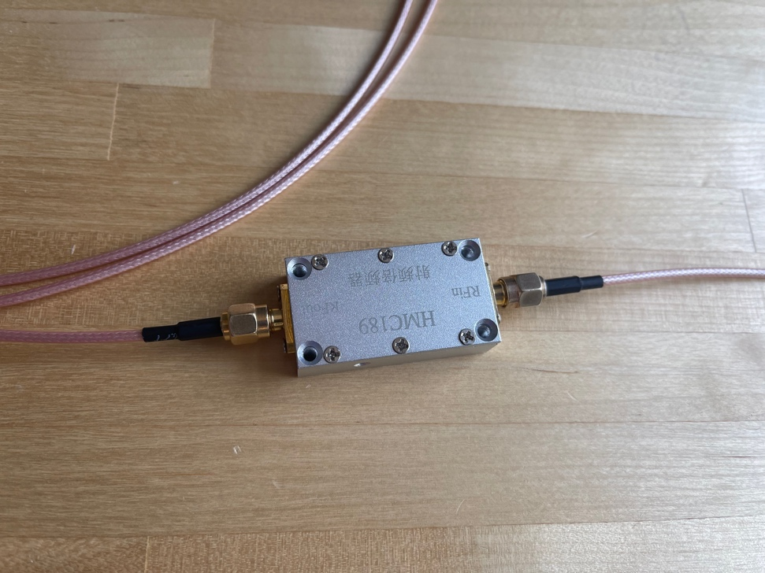
Figure 19. Setup of connections used for RG316 at the lab
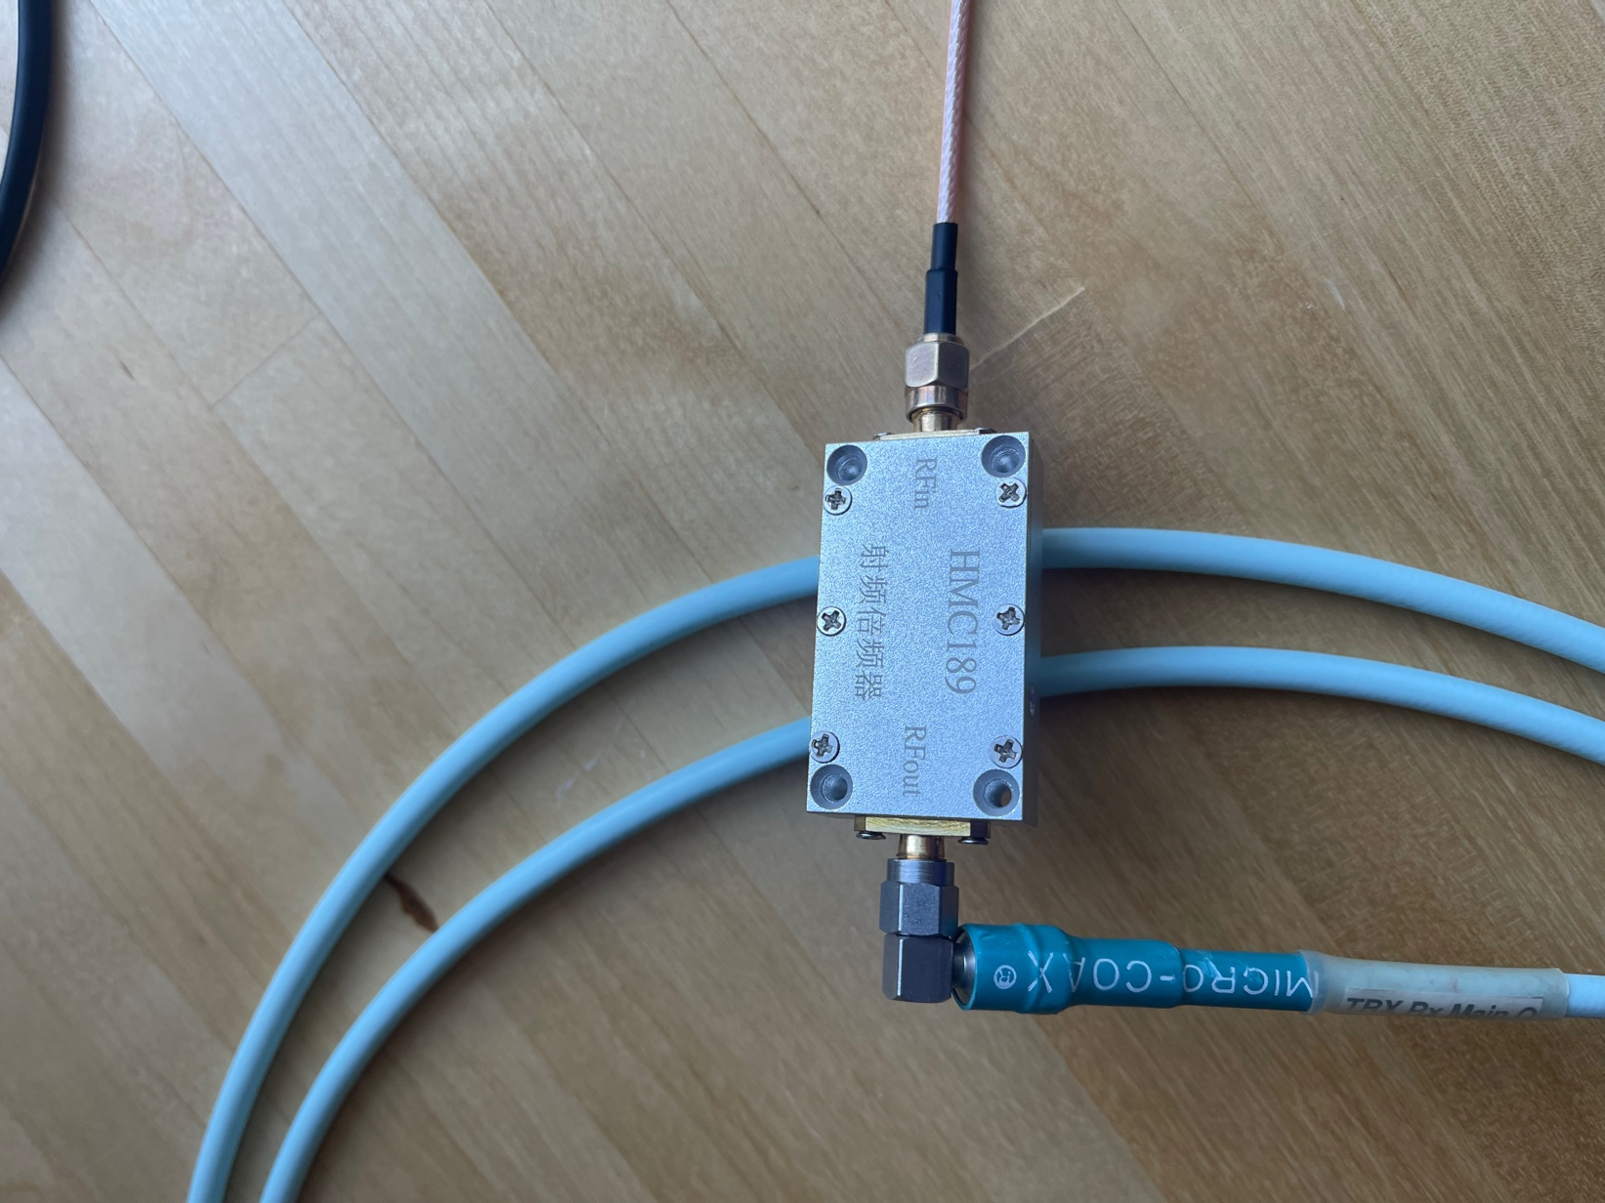
Figure 20. Setup of connections used for UFA at the lab
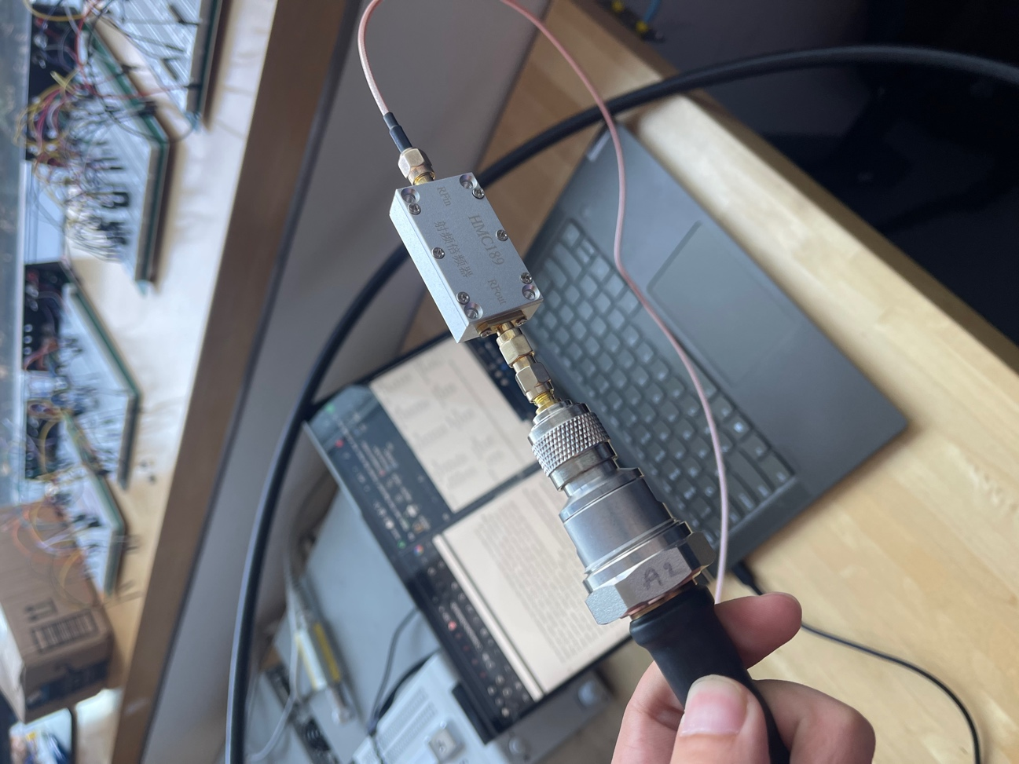
Figure 21. Setup of the connections used for Succoflex at the lab

